Testing the Referral Systems.

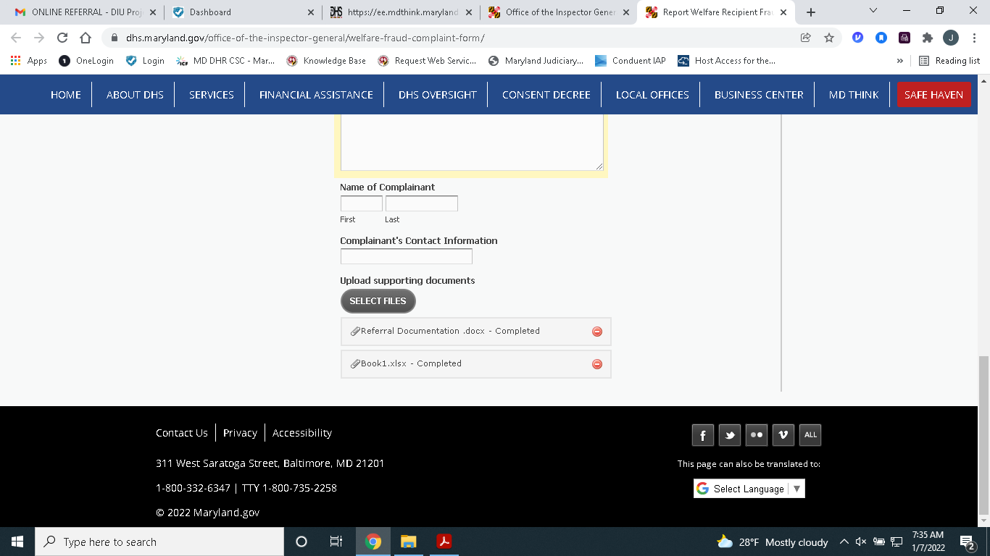

When trying to adding multiple documents the Submit button disappears.