Hi Office of the Inspector General,

I want to report a fraud with Jeanne Baxter. She is the appeal and Clearance Coordinator in Anne Arundel County Department of Human Services. Her contact information is:
Jeanne Baxter
Appeal and Clearance Coordinator
Anne Arundel County
Dept. of Human Services
7500 Ritchie Hwy.
Glen Burnie, MD 21061
Phone: (410) 421-8436
Fax: (410) 760-1608
jeanne.baxter@maryland.gov

COMES NOW, Lin Gan, respectfully files this fraud report against Jeanne Baxter, and states as follows:
1. That Lin Gan has been awarded sole physical custody of minor child Sarah Gan, born, September 19, 2008 as ordered by the Honorable PRINCE GEORGE'S COUNTY COURT case CAD13-12909. See ORDER OF THE COURT attached hereto labeled Exhibit A.
2. That minor child Sarah Gan has a panic attack on October 18, 2019 and thoughts of killing herself when she is with her mother. The school guidance counseling officer contacted the Anne Arundel County Police and Department of Social Services State of Maryland Child Welfare Services. A SAFETY PLAN was in place against her mother MARIA AUXILIADORA RODRIGUEZ YILO. See SAFETY PLAN attached hereto labeled Exhibit B.
3. Sarah stated that she would try to harm/kill herself if she returns to her mother's home. The mental injury caused by her mother has been reviewed and confirmed by three independent sources: (1) State of Maryland Child Welfare Services. See SAFETY PLAN, attached hereto labeled Exhibit B. (2) Sheppard Pratt hospital. See Photo Print, attached hereto labeled Exhibit C. (3) State of Maryland In-Home Family Services. See INTENDED ACTION LETTER, attached hereto labeled Exhibit D.
4. Jeanne Baxter conducted a preliminary appeal using teleconference with MARIA AUXILIADORA RODRIGUEZ YILO on April 22, 2020 and decided to change the finding from "unsubstantiated" to "ruled out" child neglect. This action was done without involving Lin Gan and Sarah Gan. See Summary of Conference attached hereto labeled Exhibit E.
5. The Summary of Conference from Exhibit E indicated Jeanne Baxter failed to contact Lin Gan.
6. The Summary of Conference from Exhibit E indicated Jeanne Baxter failed to review all supporting documents from Exhibit B, C and D that clearly justified the neglect.
7. The Summary of Conference from Exhibit E demonstrated that Jeanne Baxter allowed Maria to provide additional document information to the record. This information was never presented while the case was still open with the Department of Social Services. The DSS agent Tracy closed the case on February 3, 2020.

Jeanne Baxter failed to handle this case fairly resulting in the possibility of Sarah Gan in harm or in danger if returned to her mother.

WHEREFORE, the Lin Gan prays:
a. Jeanne Baxter apology for miss handling action from this case.
b. Reverse the wording change action to the case from Jeanne Baxter.
c. Remove the additional information and document indicated in Exhibit E from record.
d. Modify the case finding as “MARIA AUXILIADORA RODRIGUEZ YILO found” child neglect.

Lin Gan
Respectfully Submitted

Exhibit A

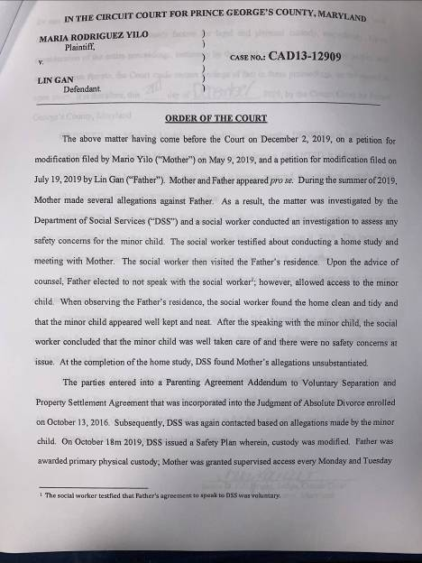

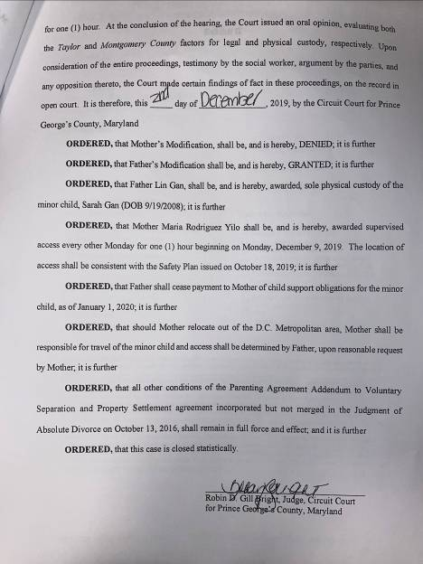
Exhibit B

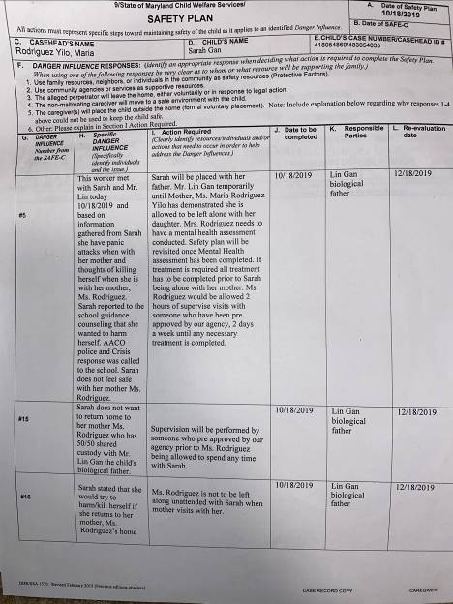

Exhibit C

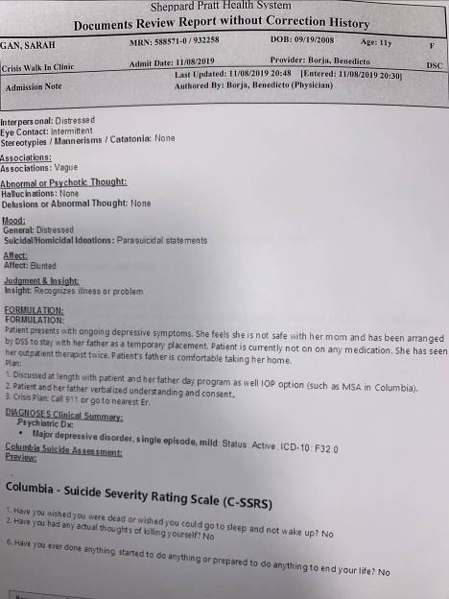
Exhibit D

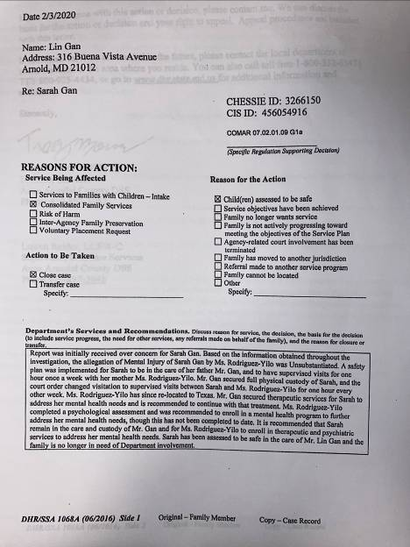
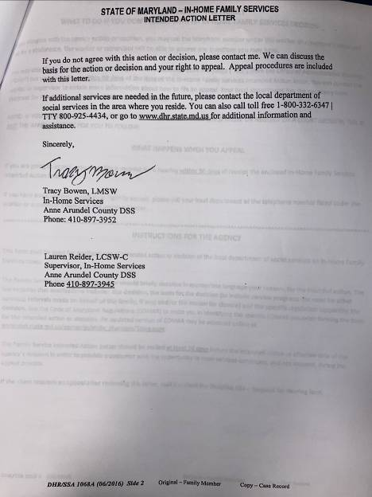

Exhibit E

